YOLOv4 Traffic Sign Detection Code

# Here we have used Kaggle Dataset

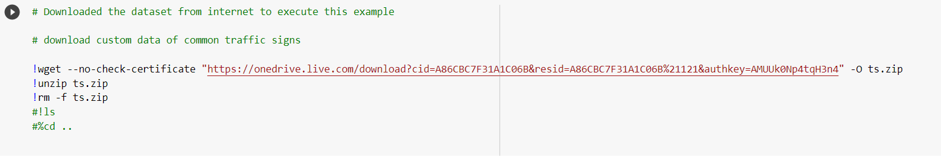

# Our Classes(4 classes)

Speed Limit  
Yield  
Mandatory  
Others

# Cloning the Darknet Repository

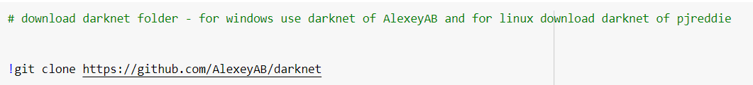

# **Changes to do in yolov4 architecture as per your dataset**

### Open darknet folder -> cfg folder -> yolov4-custom.cfg

#### Note: Delete everything from this "cfg" folder but don't delete yolov4-custom.cfg.

This step is optional. We are just deleting all these files to simply the process. Those files are extra, not required for executing yolov4

### Open yolov4-custom.cfg file and do the changes as per your dataset Training

#### change batch=1 from batch=64

#### change subdivisions=1 from subdivisions=16

#### width=608 #416

#### height=608 #416

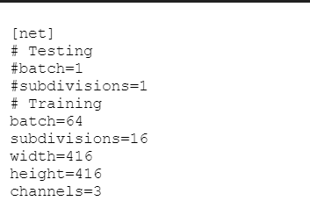

#### Next is max_batches.This parameter is very very important.The thing to remember here is that minimum batch value would be 6000 ( if you have 1 class or 2 classes or 3 classes.)

#### In our case we have 4 classes. So max_batches would be 4*2000 = 8000 i.e 8000 would be the max_batches.

#### Steps are also important. There are 2 steps:Ist step should be 90% of the max_batch value. And 2nd step would be the 80% of the max_batch

#### steps are steps=7200,6400 (90% of 8000 and 80% of 8000)

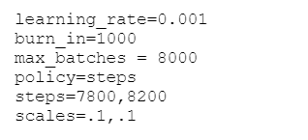

### We have 3 YOLO layers for 3 different scales.

#### Showing you a demo below. Just see the [Yolo] layer. Above [YOLO] layer, we have [convolutional] layer. Change the number of

#### filters as per your output classes as per this calculation (classes+5)3 = (4+5)3 = 27

# **[convolutional]**

size=1 stride=1 pad=1 filters=255 # change this to 27 activation=linear

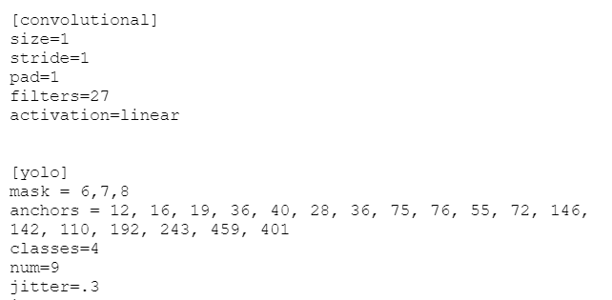

# **[yolo]**

## In the same way search for other 2 [Yolo] layers and then the [Convolutional] layer which is above the [yolo] layer. Just change the number of filters

# **Also change the number of classes as per your dataset.**

# **Next Change is open Darknet folder -> data folder**

#### Delete everything from this folder except labels folder. Don't delete Labels Folder

#### Under this data folder paste your dataset folder (images with their text files)

# **Now create 2 files data.obj and data.names in the darknet -> data .**

### data.obj have details like how many classes you have, path of your training and test file. Also mentioned the path where we want to store the trained model weights.

# Making Changes in Makefile

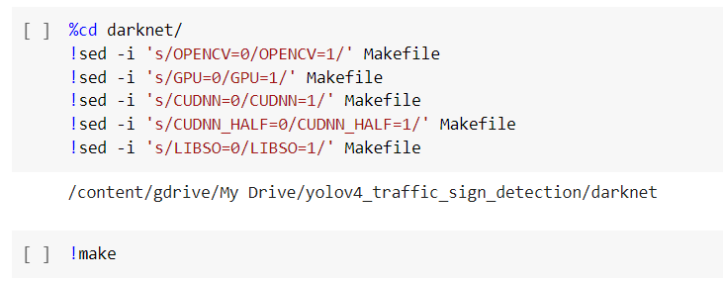

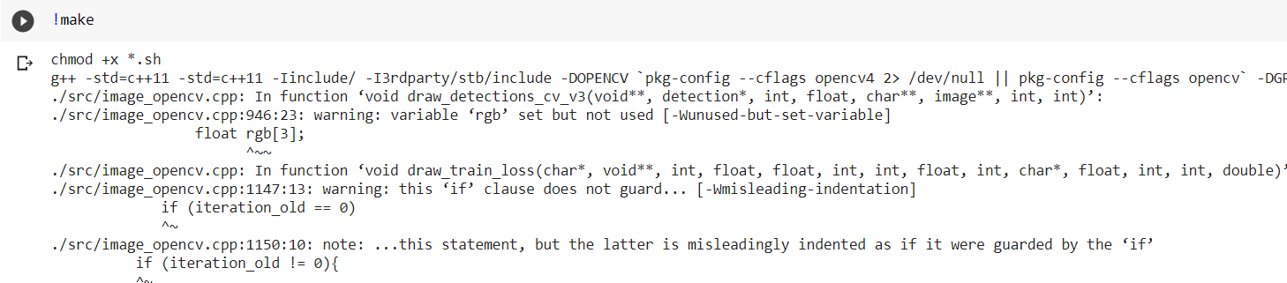

# Downloading Yolo Weights



# Training Our Model

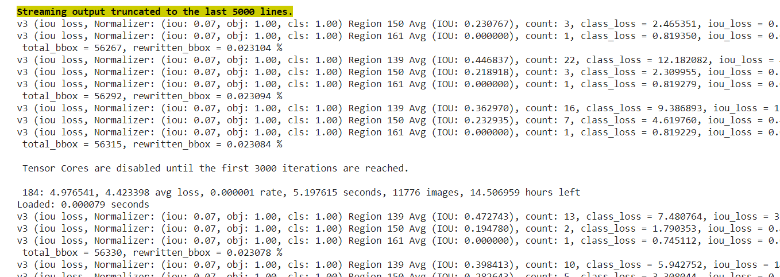

# Performance of Trained Weights

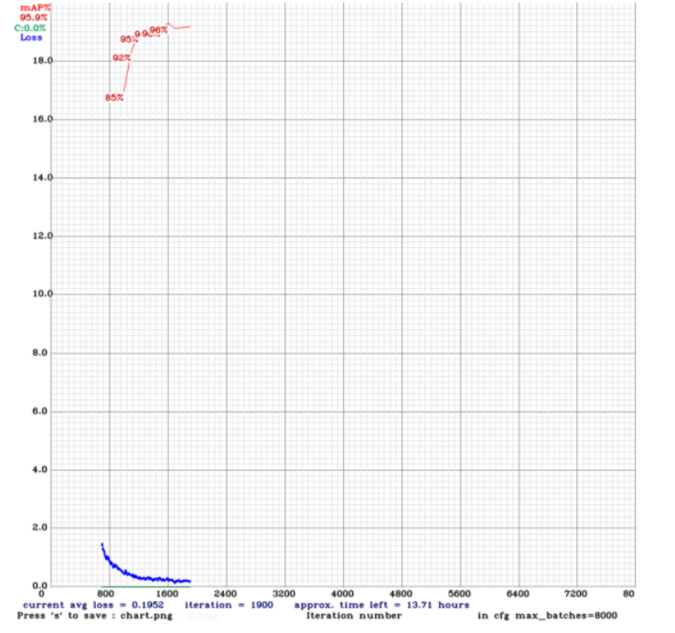

# Testing the Model

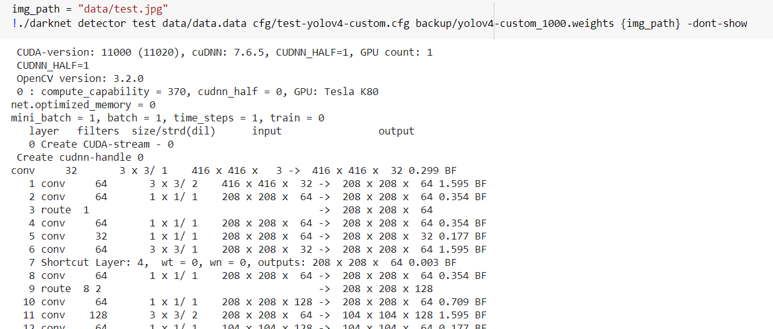

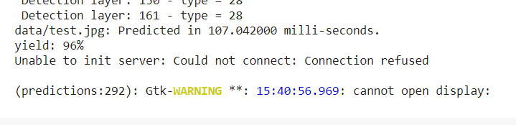

It Shows the Yield Class with 96% Probability.

